Performance Measures: Categorical Target variables

Confusion Matrix-based Performance Measures
Confusion matrices are a convenient way to fully describe the performance of a predictive model when applied to a test set. They are also the basis for a whole range of different performance measures that can highlight different aspects of the performance of a predictive model. The simplest performance measure we can use to assess how well a model has performed for a predictive classification problem is the misclassification rate. The misclassification rate is the number of incorrect predictions made by the model divided by the total number of predictions made. The opposite of this is classification accuracy which is the number of correct predictions made by the model divided by the total number of predictions made.
The confusion matrix is a very useful analysis tool to capture what has happened in an evaluation test in a little more detail and is the basis for calculating many other performance measures. The confusion matrix calculates the frequencies of each possible outcome of the predictions made by a model for a test dataset in order to show, in detail, how the model is performing. For a prediction problem with a binary target feature (where, by convention, we refer to the two levels as positive and negative), there are just four outcomes when the model makes a prediction:
True Positive (TP): an instance in the test set that had a positive target feature value and that was predicted to have a positive target feature value
True Negative (TN): an instance in the test set that had a negative target feature value and that was predicted to have a negative target feature value
False Positive (FP): an instance in the test set that had a negative target feature value but that was predicted to have a positive target feature value
False Negative (FN): an instance in the test set that had a positive target feature value but that was predicted to have a negative target feature value
There are two ways in which the prediction made by a model can be correct—true positive or true negative—and two ways in which the prediction made by a model can be incorrect—false positive or false negative. The confusion matrix allows us to capture these different types of correct and incorrect predictions made by the model.
Each cell in a confusion matrix represents one of these outcomes (TP, TN, FP, FN) and counts the number of times this outcome occurred when the test dataset was presented to the model. The structure of a confusion matrix for a binary classification is shown below. The columns in the table are labeled Predicted for positive and negative values and represent the predictions generated by a model, that is either positive or negative. The rows in the table are labeled Actual - for positive and negative values and represent the feature values that were expected. The top left cell in the confusion matrix, labeled TP, shows the number of instances in a test set that have a positive target feature value that were also predicted by the model to have a positive target feature value. Similarly, the bottom left cell in the matrix, labeled FP, shows the number of instances in a test set that have a negative target feature value that were in fact predicted by the model to have a positive target feature value. TN and FN are defined similarly.
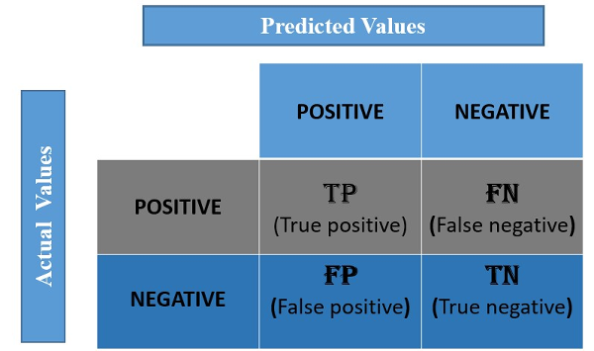

At a glance, the confusion matrix can show us that a model is performing well if the numbers on its diagonal, representing the true positives and true negatives, are high. Looking at the other cells within the confusion matrix can show us what kind of mistakes the model is making.
Consider the following result from a test set to detect spam
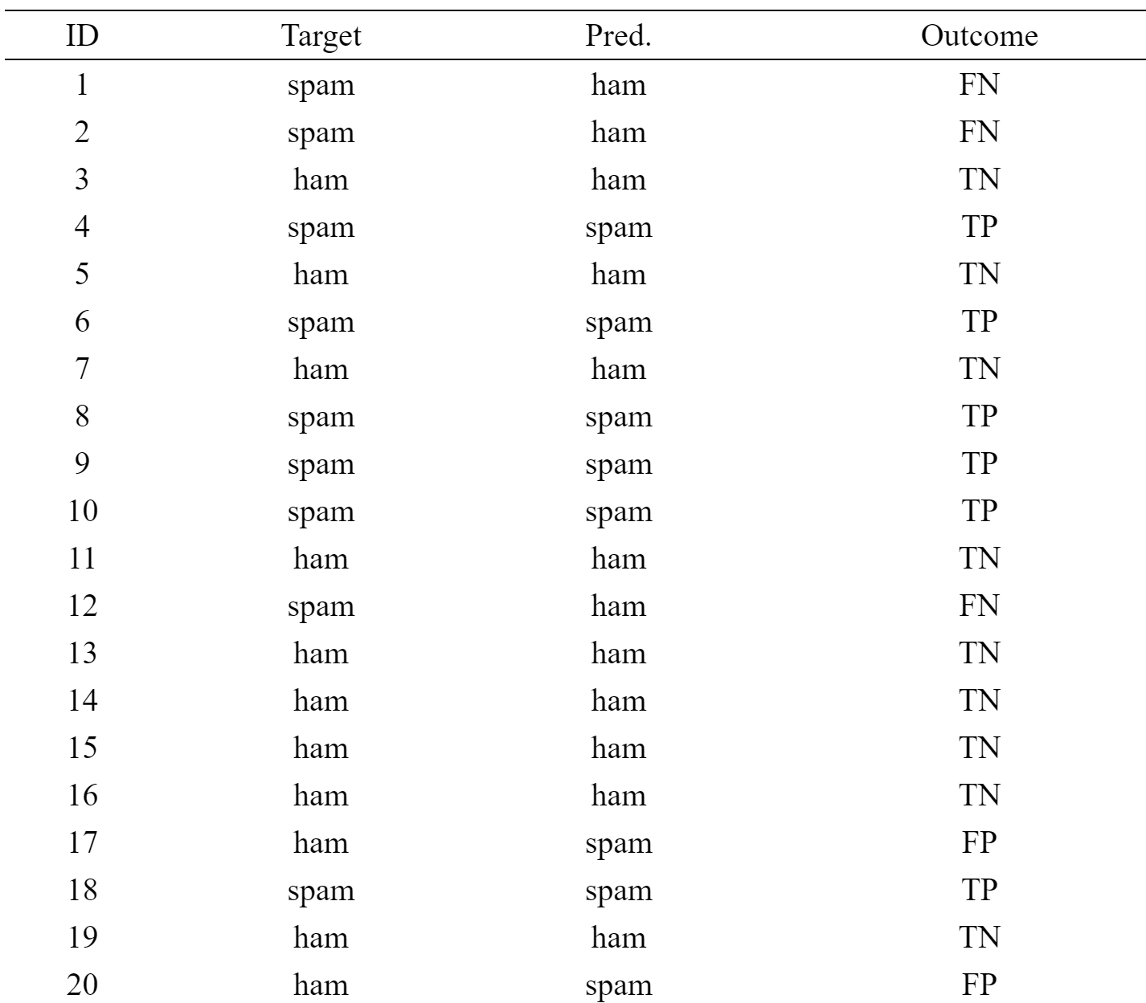
In the example shown in the table above, 20 predictions are made in total, and out of these, 5 are incorrect (instances d1, d2, d12, d17, and d20). Therefore, the misclassification rate is calculated as
misclassification rate = #incorrect predictions/total # predictions
It is usually expressed as a percentage
In our example, misclassification rate = (5/20)*100 = 25%. This tells us that the model is incorrect about a quarter of the time. Misclassification rate can assume values in the range [0, 1], and lower values indicate better performance.
The confusion matrix gives a more detailed insight into the performance of a model. The following is the confusion matrix for the table above
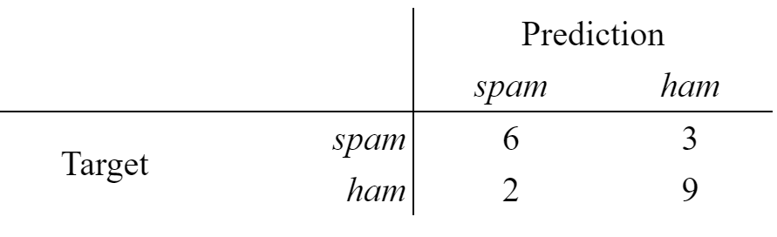
It is clear from the values along the diagonal, the true positives and true negatives, that the model is doing a reasonably good job of making accurate predictions. We can actually calculate the misclassification rate directly from the confusion matrix as follows:
(FP+FN)/(TP+FP+TN+FN)
The classification accuracy which was mentioned earlier can be calculated from the Confusion Matrix as (TP+TN)/(TP+FP+TN+FN)
We can also use the confusion matrix to begin to investigate the kinds of mistakes that the prediction model is making. For example, the model makes a prediction of ham incorrectly 3 times out of the 9 times that the correct prediction should be spam (33.333% of the time), while it makes a prediction of spam incorrectly just 2 times out the 11 times that the correct prediction should be ham (18.182% of the time). This suggests that when the model makes mistakes, it more commonly incorrectly predicts the spam level than the ham.
Another interesting metric to look at is the accuracy of the positive predictions; this is called the precision of the classifier
Precision = TP/TP+FP
So precision is typically used along with another metric named recall, also called sensitivity or true positive rate (TPR): this is the ratio of positive instances that are correctly detected by the classifier
Recall = TP/TP+FN
In practice, often a combination of PRE and REC is used, the so-called F1-score:
F1 = 2*(Precision *Recall)/(Precision + Recall)

